
CASON 2009

Welcome to the 1st Computational Aspect
of Social Networks Conference

Shuttle Bus Stop

ESIGETEL arrival
The bus shuttle will leave at 8:00 from the hotel MERCURE. It will reach the hotel IBIS (the Bus Stop is near the Post Office) a few minutes after and will go directly to the ESIGETEL (the bus is called CASON 2009).

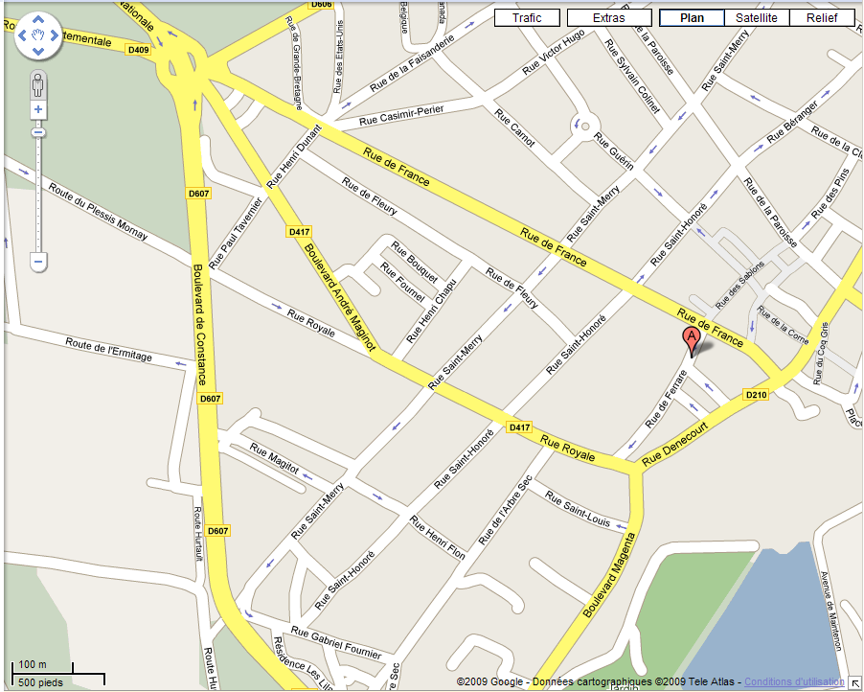
Hôtel IBIS
Post Office
Hôtel Mercure
The shuttle Bus can’t wait a long time at the bus stop.
Please be punctual!!!!

