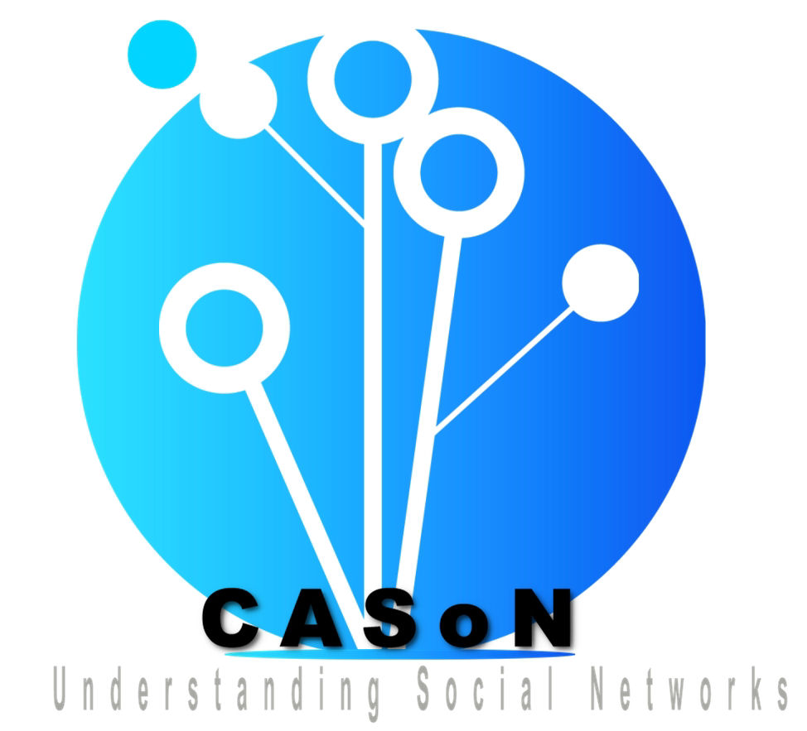
CASON 2009

Welcome to the 1st Computational Aspect
of Social Networks Conference

Etap Hotel: Shuttle Bus Stop

ESIGETEL arrival
The bus shuttle will leave at 8:00 from the hotel MERCURE in the center of Fontainebleau. It will reach the Etap hotel 10 minutes after and will go directly to the ESIGETEL (the bus is called CASON 2009)

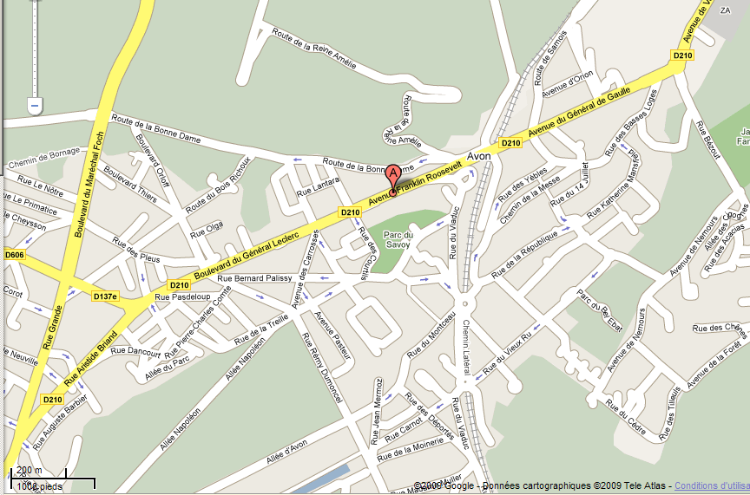
Etap Hotel
To Esigetel

The shuttle Bus can’t wait a long time at the bus stop.
Please be punctual!!!!

